Jana Vogel  Circus Artist |  | 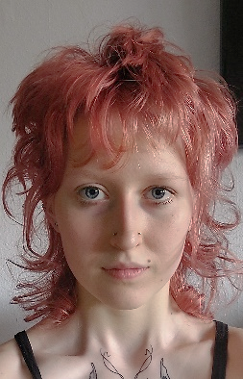
 |  | 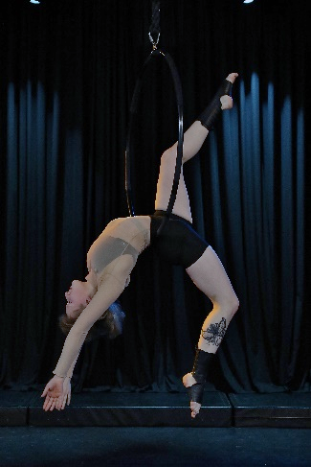
Expirience |  | Education
August 2023  GOP, Bonn — Performing Artist  GOP, Münster — Performing Artist  GOP, Bremen — Performing Artist  Circus Mondeo, Gera — Performing Artist  Kulturscheune, Herborn — Performing Artist  Graduationshow tour premiere, “Senseation”, performing a Aerialhoop and Contact Jugglin Staff act and being involved in numerous transitions.  July 2023  Kulturzentrum Franz. K, Reutlingen — Performing Artist  Friedrichsbau Variete, Stuttgart — Performing Artist  Schlossplatzfest, Coburg — Performing Artist  Gauklerfest, Koblenz — Performing Artist  Graduationshow tour premiere, “Senseation”, performing a Aerialhoop and Contact Jugglin Staff act and being involved in numerous transitions.  June 2023  Wintergarten Variete, Berlin — Performing Artist  Graduationshow tour premiere, “Senseation”, performing a Aerialhoop and Contact Jugglin Staff act and being involved in numerous transitions.  August 2022  Circus Mondeo, Gera — Performing Artist  At a local traditional circus, performing a Aerialhoop act, 6 times a week.  May 2022  Wintergarten Variete, Berlin — Performing Artist  Anniversary Event for the State School of Acrobatics Berlin. Performed a Aerialhoop act.  April 2022  Zirkus Cabuwazi, Berlin — Performing Artist  Received 3rd place at "Newcomer Artist-innen Festival 2022" with a Aerialhoop act.  January 2020  Springer Gala Velorom Berlin — Performing Artist  Anniversary for Velodrom in berlin. Performed a Aerialhoop act.  Informtion:  Height: 164cm / 5’4  Weight: 53 / 117lbs  Hair: Rosa  Eyes: Blue  Citizin: German |  | 2014-2023  State School of Circus Arts Berlin  State certified Artist  03.2022-04.2022  Coach education Schwerelos  Certified Aerialhoop coach  6.2022-07.2022  Online Fitness Academy  Certified fitness coach (B-licenz)
 |  | Disciplines
Aerialhoop (Main)
Contact juggling staff

Languages: German, English
 |  | Contact
Karower Chaussee 73, 13125 Berlin
15786763421
Janavogel.artist@gmail.com
www.janavgl.com

