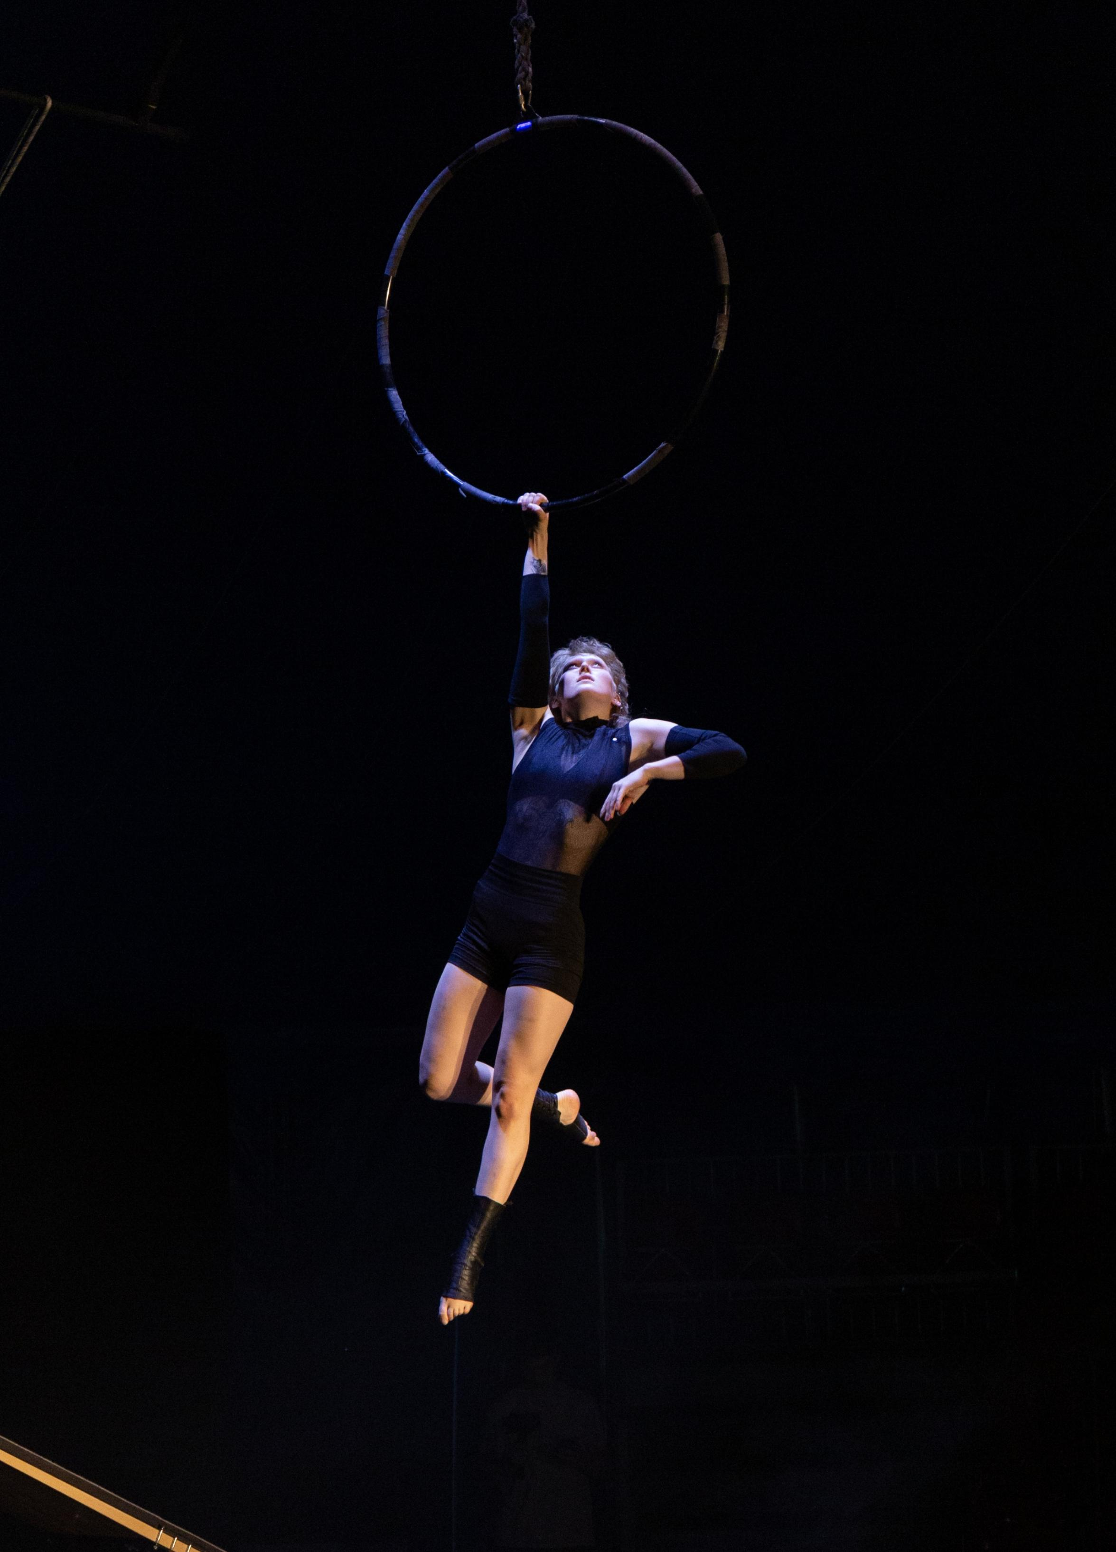  Jana Vogel  Circus Artist |  | 
Contact
Karower Chaussee 73, 13125 Berlin
15786763421
janavogel.artist@gmail.com
www.janavgl.com

Experience |  | Education
April 2024  Polemotions Studio Tübingen— Workshop  Aerialhoop workshop for all-Level on 27th of April.  March- June 2024  Friedrichsbau Varieté Stuttgart— performing Artist  Conceptshow “CIRQUE” , performing an Aerialhoop act and being involved in numerous transitions.  Feburary 2024  Guest perfomance Wasserwerk Berlin — performing Artist  Company Event via Artist Mediator, performing an Aerialhoop act.  November 2023 -January 2024  Papierfabrik Varieté Theater — Performing Artist  Conceptshow “Alarmstufe Elf” for Christmas season, performing an Aerialhoop act and being involved in numerous transitions.  June- November 2023  Absolvententour “SENSEation”, Berlin — Performing Artist  Graduationshow tour premiere, “Senseation”, performing an Aerialhoop and Contact Jugglin Staff act and being involved in numerous transitions.  Wintergarten,Berlin  GOP,Bonn, Münster, Bremen, Essen, Oeyenhausen  TAK, Lichtenstein  Circus Mondeo, Gera  Kulturscheune, Herborn  Kulturzentrum Franz. K, Reutlingen  Friedrichsbau Varieté, Stuttgart  Schlossplatzfest, Coburg  Gauklerfest, Koblenz  Superbloom, München  Stadt-Theater, Schaffhausen  Circus Luna, Hammelburg  Stadthalle, Limbach-Oberfrohna  August 2022  Circus Mondeo, Gera — Performing Artist  At a local traditional circus, performing an Aerialhoop act, 6 times a week.  May 2022  Wintergarten Varieté, Berlin — Performing Artist  Anniversary Event for the State School of Acrobatics Berlin. Performed an Aerialhoop act.  April 2022  Circus Cabuwazi, Berlin — Performing Artist  Received 3rd place at "Newcomer Artist-innen Festival 2022" with an Aerialhoop act.  January 2020  Springer Gala Velodrom Berlin — Performing Artist  Anniversary for Velodrom in berlin. Performed an Aerialhoop act. |  | 2014-2023  State School of Circus Arts Berlin  State certified Artist  03.2022-04.2022  Coach education by Schwerelos  Certified Aerialhoop coach  06.2022-07.2022  Online Fitness Academy  Certified fitness coach (B-licenz)
 |  | Disciplines
Aerialhoop (Main discipline)
Poledance (Complemantary skill)
Hula Hoop, Handstand, Contact Juggling Staff, Aerial Straps, Juggling with Balls, floor Acrobatic

Birthday: 2004
Nationality: German
Languages: German, English, French
Height: 164cm / 5’4

